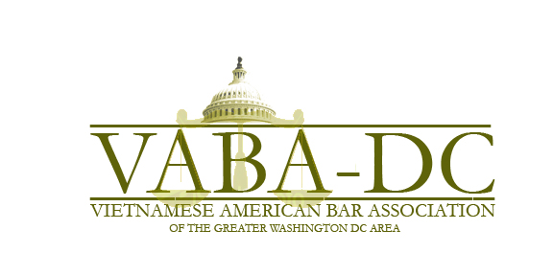
Vietnamese American Bar Association
Of the Greater Washington DC Area
(VABA-DC)
2020 Scholarship Application

VABA-DC was established, in part, to contribute to the public interest by serving as a voice for the local Vietnamese American community and assisting community members with legal concerns. In furtherance of that mission, we are proud to sponsor up a scholarship in the amount of $2,500 for law students who have served or plan to serve the Vietnamese American community or have overcome significant adversity in achieving their academic goals. Scholarship recipients are selected on the basis of community service, academic performance, ties to the Greater Washington D.C. area, and their written essay. The scholarship recipient(s) will be expected to attend the VABA-DC Scholarship Dinner in their honor to be held in April in Washington, D.C. Please refer to the VABA-DC website for more information on the Scholarship Dinner at www.vabadc.com.

Name: _____________________________________________________________________

Address: ___________________________________________________________________

Phone: (_____) __________________ E-Mail: ____________________________________

Law School: _______________________________________ Year of Graduation: _______

Undergraduate School: _______________________________ Year of Graduation: _______

Please attach the following documents to this form and send your package by e-mail to linh@nnlawfirm.com and cc’d to vabadc@gmail.com, no later than March 1, 2020:

- Resume (please include any honors and awards)
- Law school transcript
- One to two references
- An essay (not to exceed 750 words) addressing one of the following questions:
  - How do you plan to serve the needs of Vietnamese Americans in your legal career?
  - What experiences have you had in serving the Vietnamese American community?
  - How have you overcome barriers in your life to achieve your academic and/or career goals?
- Signed Scholarship Terms (below)
Scholarship Terms:

I, the undersigned applicant, understand that if I am awarded a VABA-DC Scholarship (“Scholarship”), I must be enrolled as a law student at least half-time and be in good standing at an ABA- or AALS-accredited law school at the time of the award.

I understand that I must use the scholarship funds for tuition, course-related expenses, or reasonable living expenses while enrolled in law school. I understand that any finding by VABA-DC that I have failed to comply with these terms will result in the forfeiture of the Scholarship, and that VABA-DC, in its sole discretion, may compel the return of the entirety or required portion of the Scholarship upon written demand. Failure to return these monies may result in collection efforts and legal action against me. To the extent allowable by law, the recipient will be responsible for all costs, fees, and expenses incurred by VABA-DC in seeking recovery of the award monies.

I understand that officers and directors of VABA-DC and members of the VABA-DC Scholarship Dinner committee, as well as their immediate families, are ineligible for the Scholarship. I also understand that all materials submitted to VABA-DC will become property of VABA-DC and that VABA-DC reserves the right to issue public announcements regarding Scholarship award winners and to publish their essays.

I understand that if I am the recipient of the scholarship, I will be required to attend the VABA-DC Scholarship Dinner in Washington, D.C. to be held in April 2020 (the exact date is TBD). I understand that VABA-DC may not be able to pay for any expenses, including transportation and lodging, in connection with my attendance at the Scholarship Dinner & Banquet.

I certify that all statements and information contained herein and in all application materials submitted by me are true, correct, and accurate to the best of my knowledge. I understand that I am required to immediately notify VABA-DC of any material error or omission in my application materials. I certify that the essay attached hereto was written solely by me and is my original work.

__________________________________
Signature of Applicant

__________________________________
Print Name

__________________________________
Date

